PreCalc Extra Credit More on Basic Trig Name: __________

We have known the exact value of the basic trig for

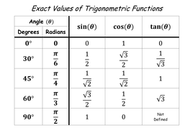

Can we find the exact value for some other more?

Given two congruent isosceles right triangle BAC and BDE as shown.

Let AB = AC = BD = DE = 1

Find the measurement of angle DEC and DCE

Now find the exact value of the basic trig for 22.5o and 67.5o

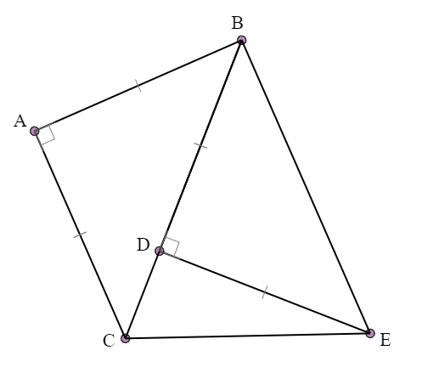

Given two congruent 30-60-90 triangle BAC and BDE as shown.

Let AC = DE = 1 and BC = BE = 2

Find the measurement of angle DEC and DCE

Now find the exact value of the basic trig for 15o and 75o

